**User Manual – NER Annotation Platform**

**1. Introduction**

This platform is designed to support Named Entity Recognition (NER) annotation tasks. It allows users to upload documents, annotate text, manage tags, and track progress. There are functionalities available for both Admins and Annotators.

**2. System Requirements**

* Python 3.8 or higher
* Django framework
* SQLite (default) or another supported database
* Web browser (Chrome/Firefox recommended)

**3. Installation and Setup**

**Step 1:** Install dependencies

pip install -r requirements.txt

**Step 2:** Run database migrations

python manage.py migrate

**Step 3:** Start the Django server

python manage.py runserver

**Step 4:** Run fastAPI microservice for each model(general,medical and financial)

python -m uvicorn server:app --host 127.0.0.1 --port 8004 --reloads# for general

python -m uvicorn server_fin:app --host 127.0.0.1 --port 8004 --reloads# for financial

python -m uvicorn server_med:app --host 127.0.0.1 --port 8004 --reloads# for medical

**4. Logging In**

**Step 1:** Open your browser and go to <http://127.0.0.1:8000/>

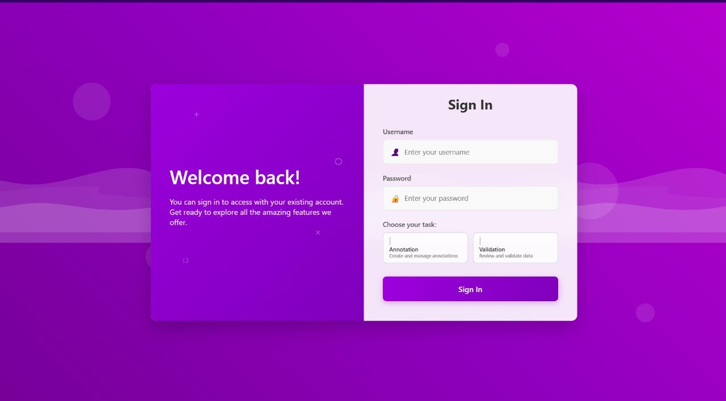

**Step 2:** Enter your username and password and choose whether you are an annotator or validator

**Step 3:** Click “Login” to access your dashboard

**5. Admin functionalities**

**----- Uploading Files -----**

**Step 1:** Log in as Admin (user:admin , password:admin)

**Step 2:** Navigate to the file upload section

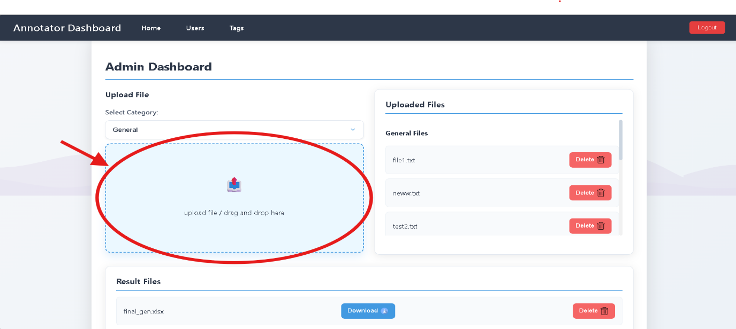

**Step 3:** Select the domain (general/financial/medical)

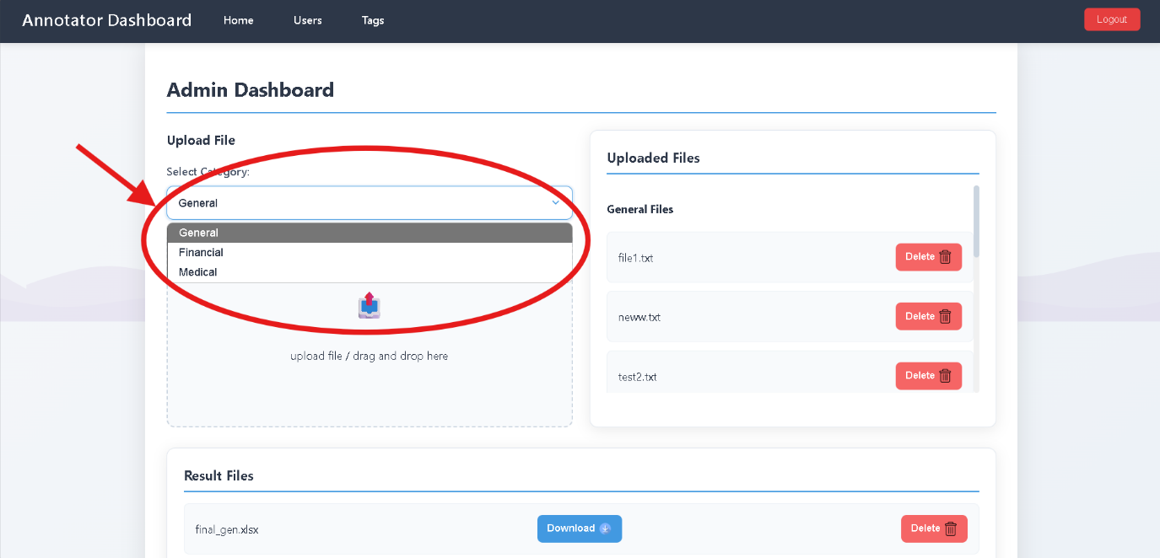

**Step 4:** Choose a .txt file

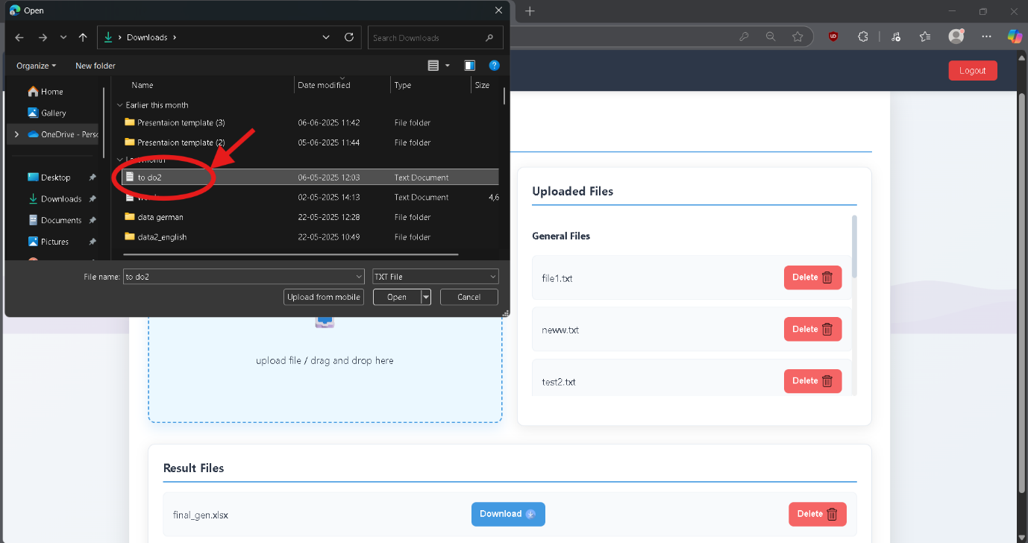

**Step 5:** Click **Ok**

**----- Adding user -----**

**Step 1:** Click on add user

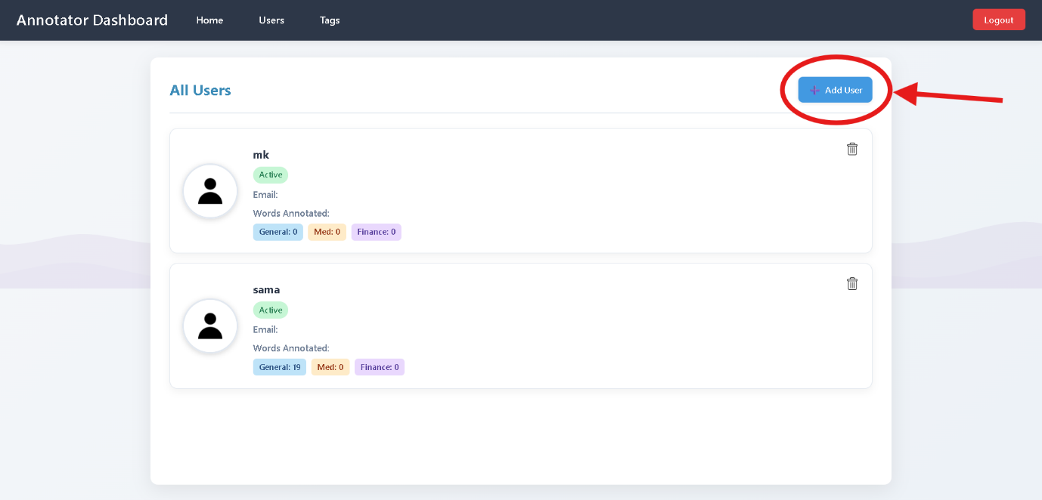



**Step 2:** Enter user details and click “add user”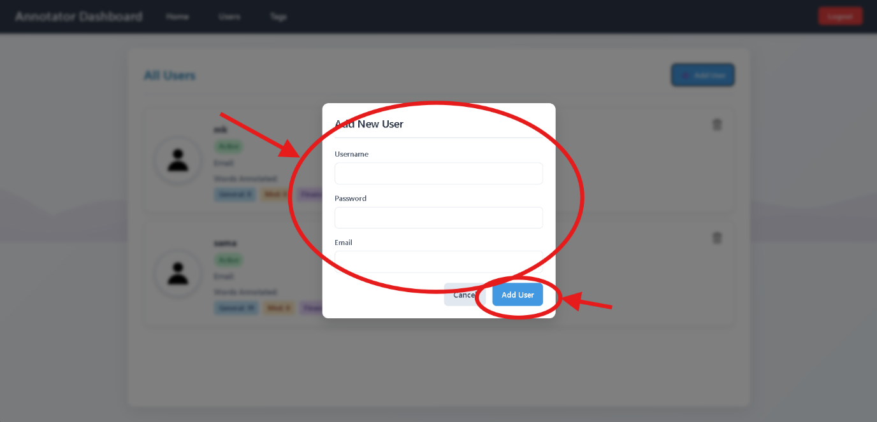

**----- Adding tags -----**

**Step 1:** Click on add tag in tags section

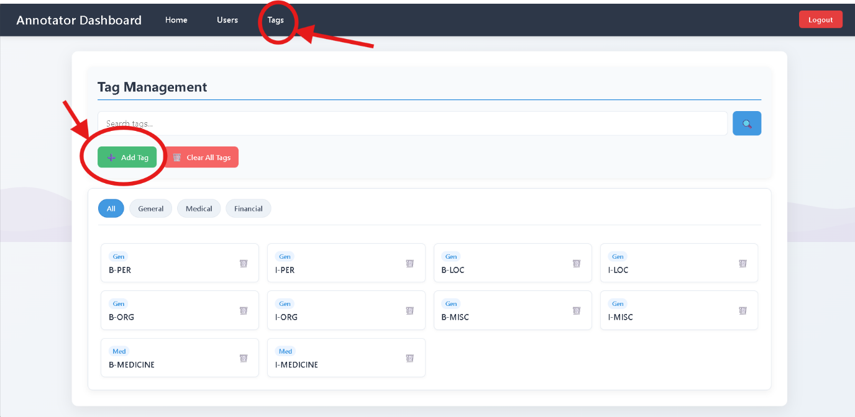

**Step 2**: Select domain, enter tag name and click on “add tag”

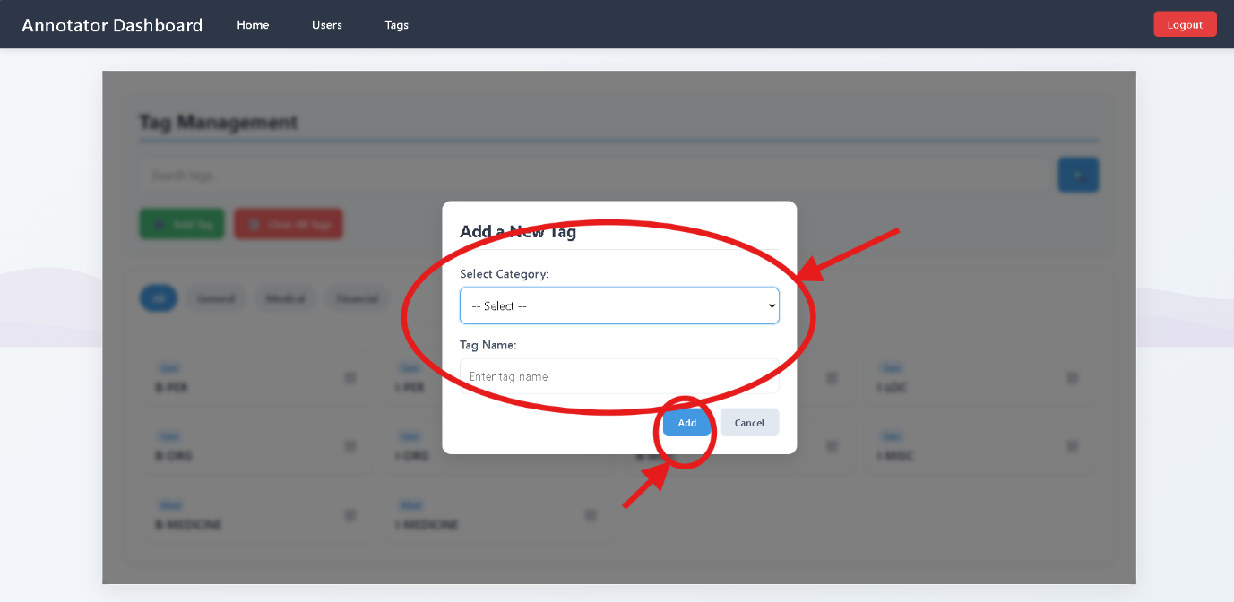

**6. Annotating Text**

**Step 1:** Select a domain

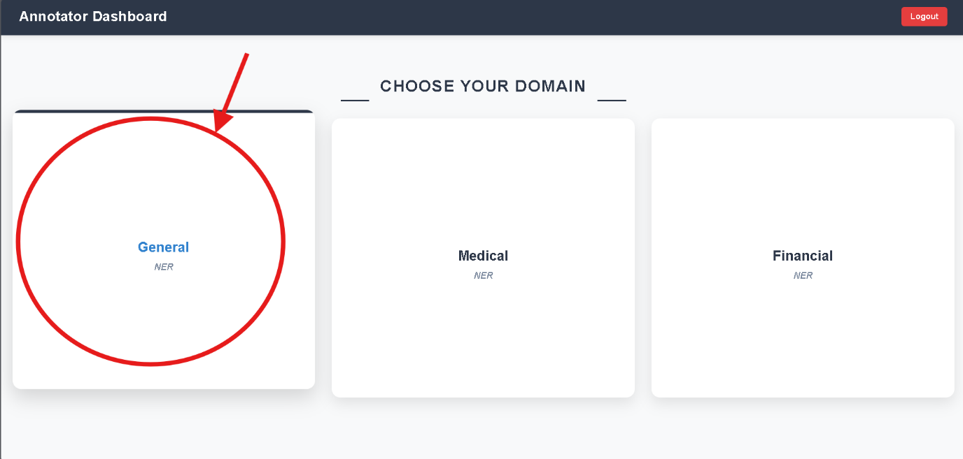

**Step 2:** Read the paragraph displayed, select a word, select/search for a tag and click on “add tag”, use “auto tag” for assisted tagging from custom BERT models

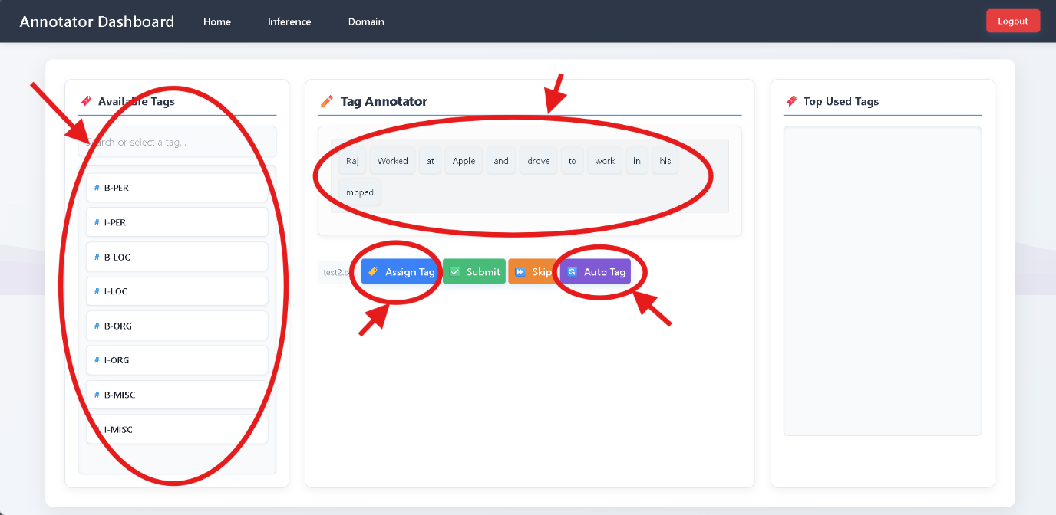

**Step 3:** Click “Submit” to submit the file (you can choose to partially submit the annotated lines by using “save and submit” or entire file by using “submit anyways” )/”skip**”** to skip the file

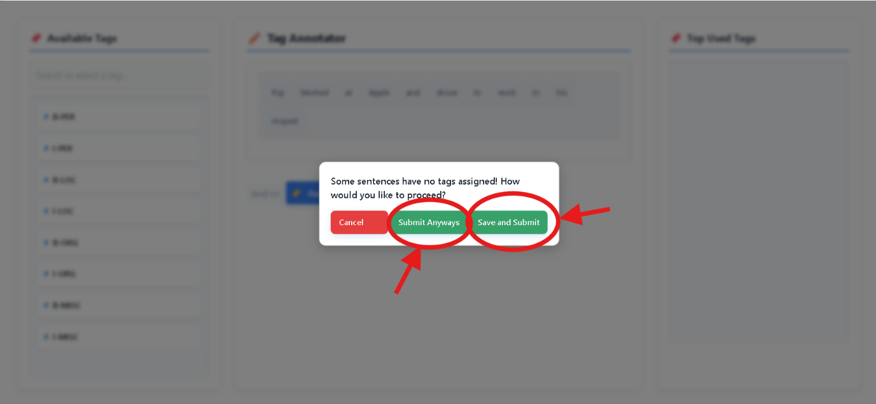

Repeat this for different files

**7. Logging In as a Validator**

**Step 1:** Open your browser and go to [**http://127.0.0.1:8000/**](vscode-file://vscode-app/c:/Users/soura/AppData/Local/Programs/Microsoft%20VS%20Code/resources/app/out/vs/code/electron-sandbox/workbench/workbench.html) **Step 2**: Enter your username and password **Step 3:** Select **"Validation"** as the task type **Step 4:** Click Login to access the validation dashboard  
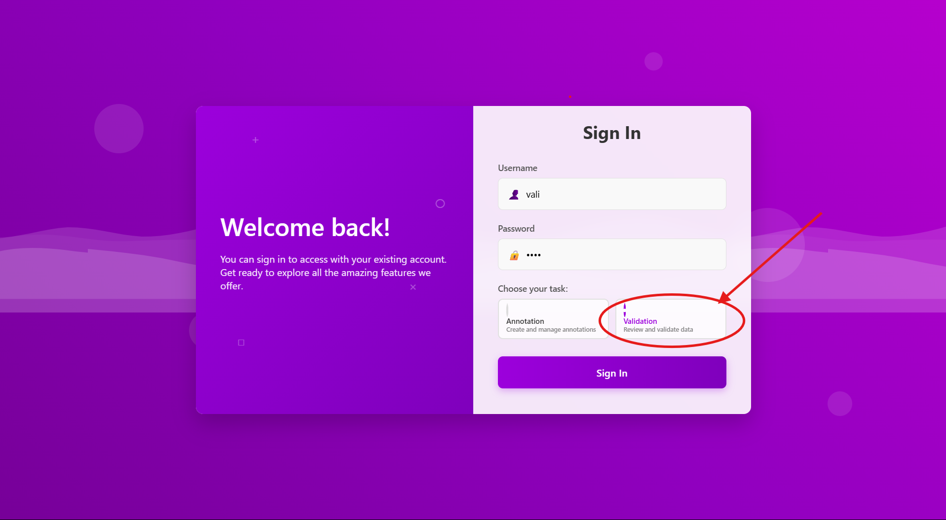

**8. Selecting a Validation Domain**

**Step 1:** After logging in, you will be directed to the domain selection page **Step 2:** Choose the domain you want to validate: **General, Medical, Financial   
Step 3:** Click on the selected domain to proceed to the validation workspace

**6. Validating Annotations**

**Step 1:** Review the annotations displayed on the screen  
**Step 2:** Check if entities are properly tagged with appropriate labels **Step 3:** For each annotation set:

* If correct: Click **"Valid"** button
* If incorrect: Click **"Invalid"** button

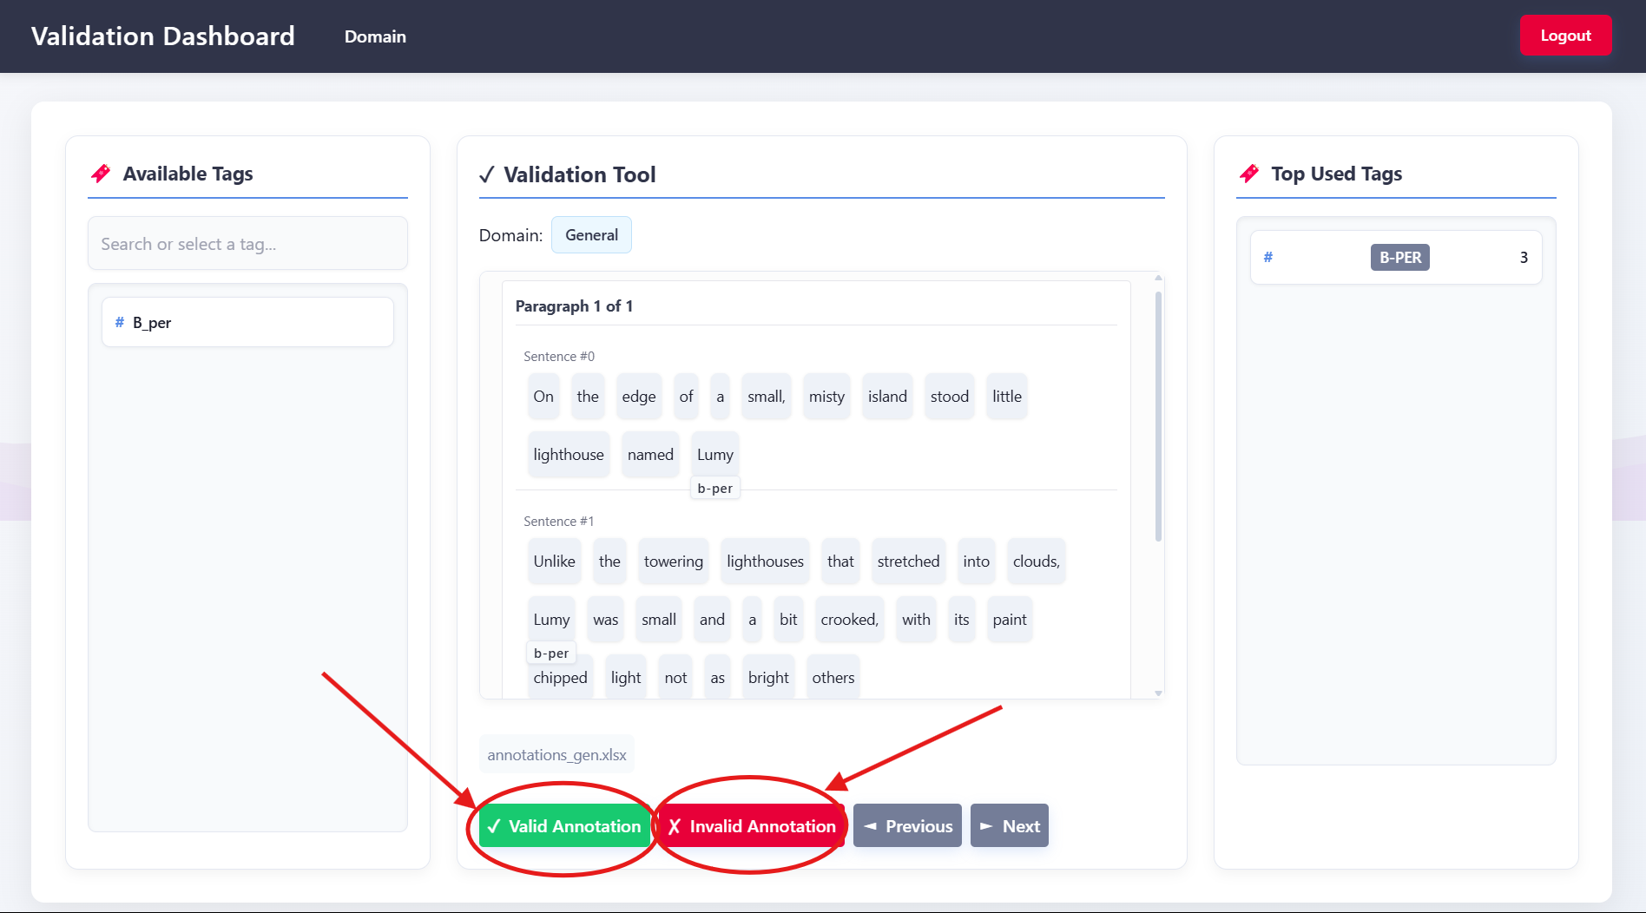

**9. Troubleshooting**

* **Login fails:** Ensure correct credentials or contact admin
* **Tags not saving:** Check internet connection and session timeout
* **File upload fails:** Verify file is plain text (.txt) and within allowed size
* **Model Usage:** Ensure models are running before running the website
* **Login Roles**: Don’t use admin login to do annotations